1200Mbps Hotspot/WiFi Repeater

Banish WiFi Deadspots Around Your Home
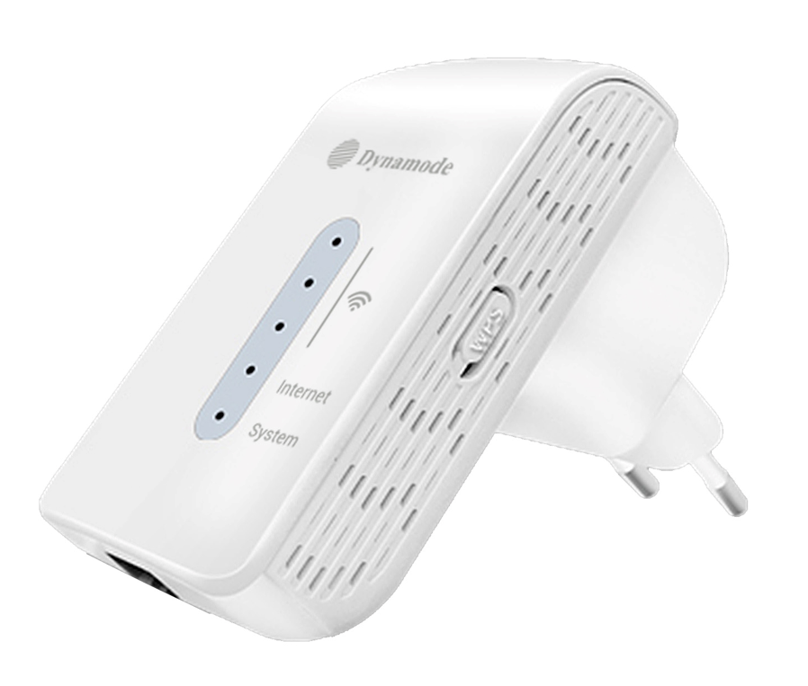

Features:

- Banish WiFi Deadspots, intermittent WiFi connections
- Superfast WiFi With Upto 1200Mbps Data Throughput
- Automatically Connects to Either 2.4Ghz or 5Ghz WiFi
- WiFi Beamforming Technology For All-Round Coverage
- Super-Secure Encryption To Help Mitigate Data Breaches
- Integral UK Power Plug - Low Profile Stylish Design

Specifications
