3.5" External SATA Hard Disk ENCLOSURE

Simply Add Your Own 3.5" Hard Disk
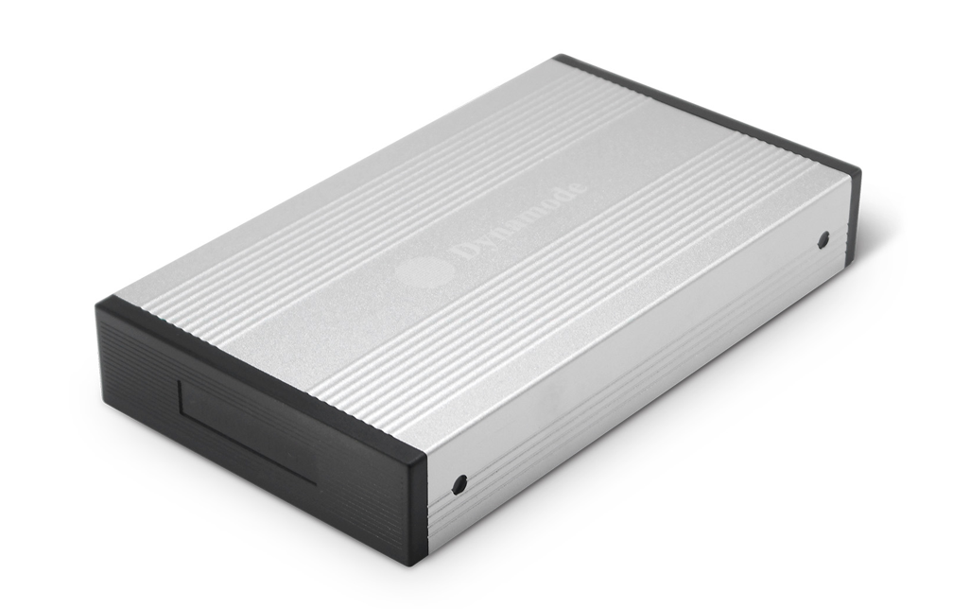

DESCRIPTION
The stylish USB-HD3.5SI-1-A features a high quality aluminium enclosure and is ideal for your existing 3.5" SATA or IDE interfaced hard disks.

Fully Plug n' Play for leading Operating Systems including Microsoft Windows and Mac OS X, the USB-HD3.5SI-1-A allows your existing hard disk to be fitted quickly and with minimal effort.

FEATURES
> Stylish and portable aluminium design
> Ideal for your existing 3.5" interfaced hard disk drives
> Re-use your PC, Server or Mac hard disk and keep your data
when you upgrade
> Plug n' Play for popular Operating Systems -
no drivers needed
> External PSU supplied
> Backup and restore your data at up to 480Mbps

SPECIFICATIONS
Transfer interface: USB2.0
Transfer data: 480Mbps(MAX)
Hard disk type: 3.5" SATA or IDE interfaced hard disk
Working temperature: -40 ~ 65℃
Working humidity: 8% ~ 90%
Storage humidity: 5% ~ 95%
Operating systems: Windows98/ME/2000/XP/VISTA/7/8/10, Mac OS 8.6 or above

