3.5" External SATA Hard Disk ENCLOSURE

Simply Add Your Own 3.5" Hard Disk
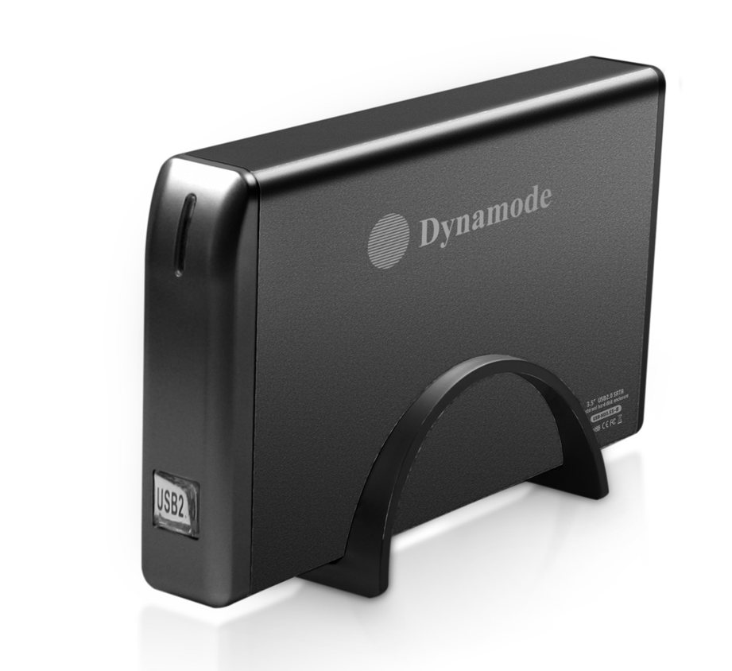

DESCRIPTION
The stylish USB-HD3.5S-Bfeatures a high qualityaluminum Enclosure which comes with a verticalstand pedestal to take less desktop space, ideal foryour existing 3.5" SATA interfaced hard disks.
Fully Plug n'Play for leading Operating Systemsincluding icrosoft Windows and ac OS x, the USB-HD3.5S-Ballows your existing hard disk to be fittedquickly and with minimal effort.

FEATURES
> Stylish and portable aluminum design
> Ideal for your existing 3.5" SATA interfaced hard disk drives
> Re-use your PC, Server or Mac hard disk and keep your data
when you upgrade
> Plug n' Play for popular Operating Systems -
no drivers needed
> External PSU supplied
> Backup and restore your data at up to 480Mbps

SPECIFICATIONS
Transfer interface: USB2.0
Transfer data: 480Mbps(MAX)
Hard disk type: 3.5" SATA interfaced hard disk
Working temperature: -40 ~ 65℃
Working humidity: 8% ~ 90%
Storage humidity: 5% ~ 95%
Operating systems: Windows98/ME/2000/XP/VISTA/7/8/10, Mac OS 8.6 or above



