Specxellent Reading Glasses. Ultra-Clear Vision with a Smooth Feel and Classy Design
RGL902-PUR-1

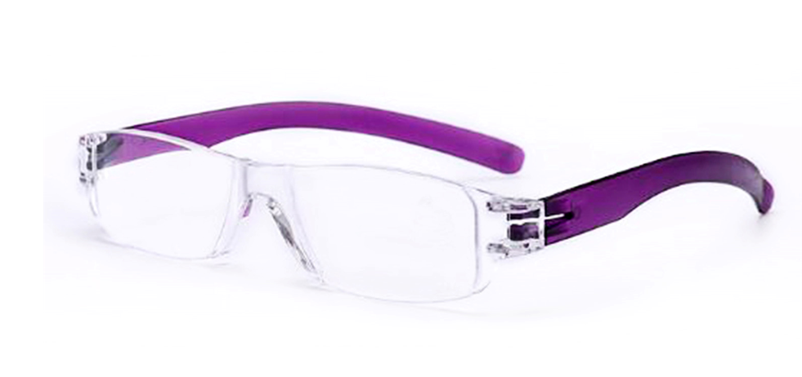

- Stylish Design and comes in 5 Colours: Black, Blue, Red, Brown and Purple
- Sleek & Sturdy with Spring Hinges makes the readers strong and durable
- These reading glasses brought to you by Specxellent are fashionable, stylish, and excellent value for money. Perfect for reading your favourite book, reading the newspaper, or working on your laptop or computer
- We've got pairs of reading glasses ranging in a variety of different magnification strength. We currently have available: +1.50, +2.00, +2.50, +3.00 and +3.50

