Waterproof Underwater Case Cover Dry Bag Pouch lanyard For Mobile Phone

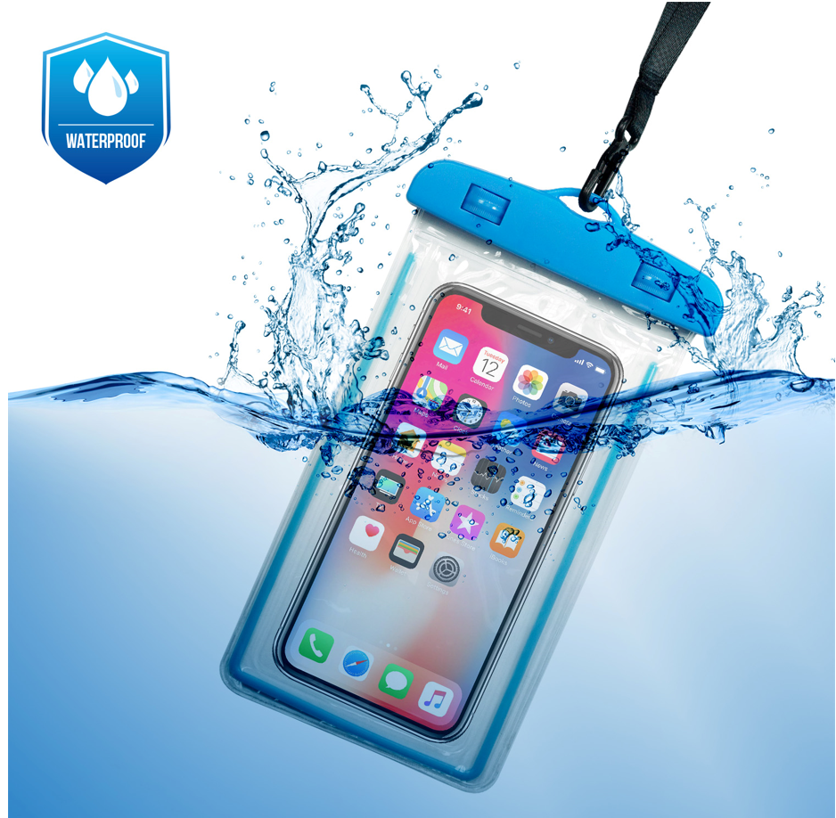

Item specifics
Condition:
New: A brand-new, unused, unopened and undamaged item in original retail packaging (where packaging ... Read moreabout the condition
Character:
Pouch
Material:
Plastic
Type:
Bag
Compatible Model:
Universal
Features:
Waterproof/Underwater
Brand:
LMSDATA
Items Included:
Strap

Specifications:
- Ideal for Mobile Phones up to 6-inches (approx.)*
- 100% waterproof technology - up to 10 metres depth
- Does not sacrifice use of the devices’ touchscreen
- Floats in water - if you drop it in, you won’t loose it
- Take movies and stills under the waves
- Prevents ingress of damaging sand, grit and dirt
- Also ideal for documents, passports, money etc
- Stylish in design, with supplied lanyard

Part number: PH-BAG-WP
Barcode:8400800030412
Weight:52.3g
Package size:264x142x14mm

