Universal MicroSD

Memory Card

with MicroSD to SD Adapter
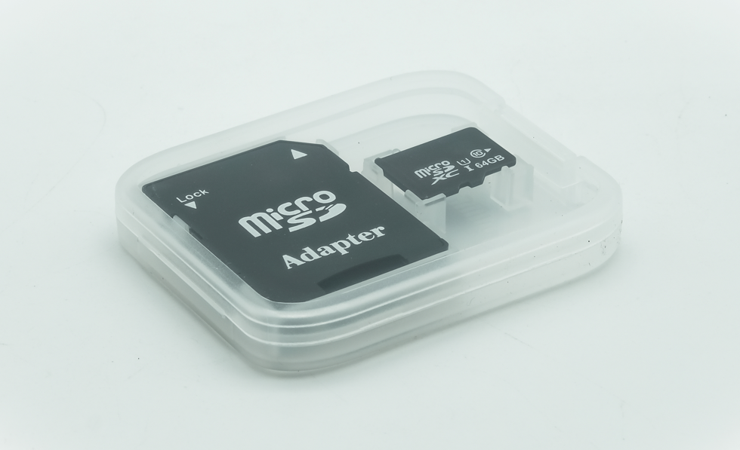

The MicroSDTM cards are ideal for storing media-rich files such as music, videos, and high-resolution images, just like the MicroSDTM and SDTM cards. In fact, MicroSDTM cards offer even more storage for the mobile world’s wide array of capacity needs. The microSDTM card delivers all of these benefits in a tiny package, marking it ideal for mobile products. testing.

The MicroSDTM format has a variety of speed classes, allowing you to find the card that meets your needs and budget. MicroSDTM cards are backward compatible with electronic devices that are SDTM enabled. By using an appropriate adapter, the MicroSDTM card can easily and quickly be inserted into any device that supports a SDTM or MicroSDTM card.

Bundled Converter - Convert MicroSDTM to full-size SDTM memory cards
MicroSDTM - High Capacity(HC)
Use Anywhere - Use existing MicroSDTM cards on full-size Computer SDTM cards slots
Standard Dimensions - 11mm x 15mm x 1mm (approx)
Temperature Ranges - minus 40F to 185F (approx)
Weight - 1.41 grams (approx)

