Dynamode ADSL Micro filter and Splitter - Lead Adapter For Broadband, Modem, Router, DECT, PABX, Phone Systems, Home and Office - BT Connection - Plug n' Play (Single, With Tail)

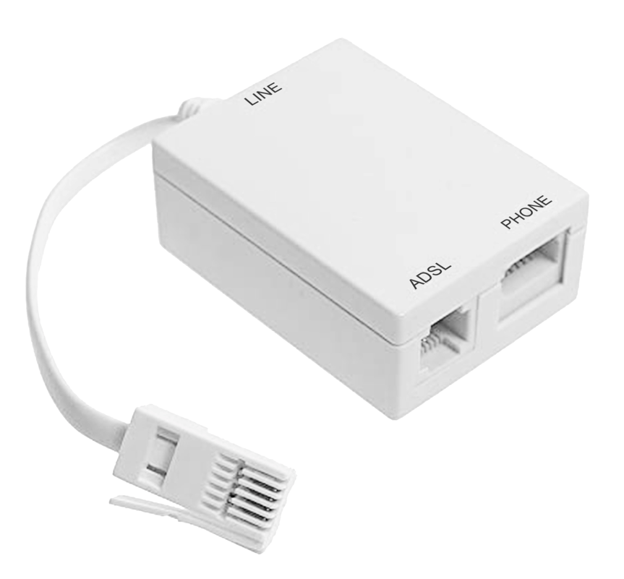
- ✔️ RELIABLE ADSL-2 FILTERING: The M-ADSL-FILTER-Y series of ADSL2+ micro filters from Dynamode will give you the extra performance you need. It has a robust build quality, long MTBF components and second-to-none post assembly testing
- ✔️ COMPATIBLE WITH LATEST ADSL2+ STANDARDS: Fully compatible with the latest ADSL2+ standards, exceeding BT SIN 346 v2.2 guidelines, the M-ADSL-FILTER series is ideal for almost all UK standard ADSL lines and compatibility is assured for use with DECT (digital) cordless phones and regular PABX (POTS) systems found in homes and businesses everywhere.
- ✔️ MINIMIZE INTERFERENCE & SIGNAL LEAKAGE: Reduce signal leakage for improved speech and data, increase performance, and enjoy a stable ADSL connection at your home or office
- ✔️ SIMPLY PLUG N' PLAY: Being Plug n’ Play means you can simply discard your low quality ADSL micro filter that came with your ADSL router and upgrade to the new Dynamode M-ADSL-FILTER series.
- ✔️ 100% SATISFACTION GUARANTEE: We strive to provide quality products and service. While our products are made of high-quality material, should you have any issue with your purchase, feel free to contact us. Your happiness with your purchase is our #1 priority!

