Male to Female Audio Splitter

Headset Adapter
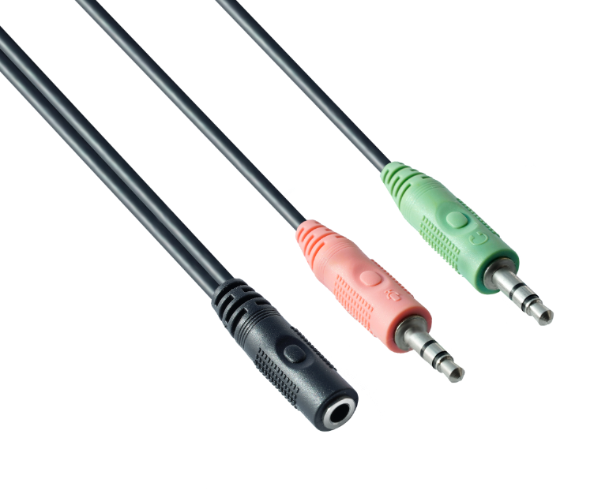

Turns a 3.5mm combo headphone/microphone port

into two distinct ports – one 3.5mm headphone jack

and one 3.5mm microphone port.



