Cable TIES
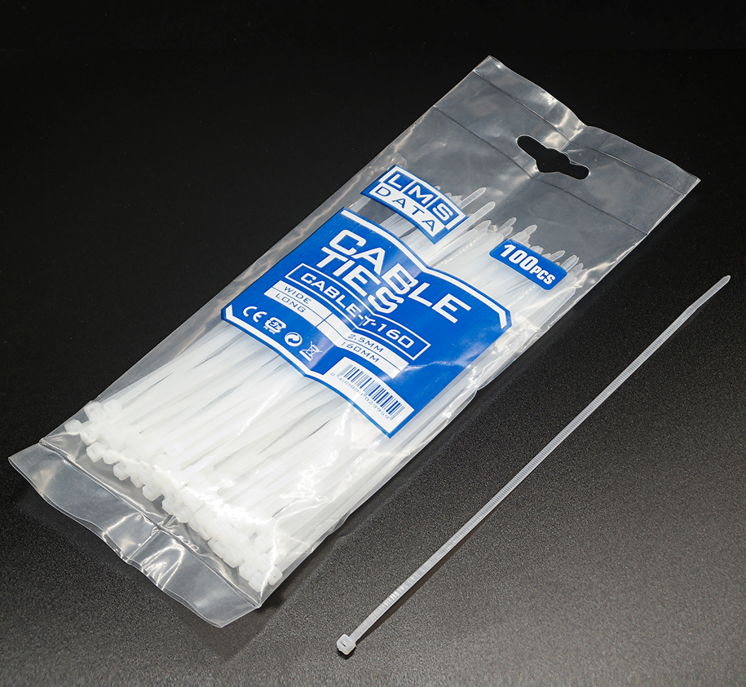

Material : | Polyamide 6.6
Wide: | 2.5mm
Long: | 160mm
Flammability Of Raw Material : | UL 94 - V2
Humidity Absorption : | 2,7%-2,8% (23°C -50% R.H.)
Installation Temperature : | -10°C ~+85°C
Working Temperature : | -40°C ~+85°C
Max Sustaiaable Tempeature For Short Time:Certificate: | +110°C
Features： | Releasable cable ties are available in two different designs. One design has an extended pawl or locking mechanism in the head of  the tie which can be released with a thumbnail force. The second design has a large horizontal tab feature which releases the tie  with a push onto the tab.
Features： | Good resistance to bases, oils, greases, oil derivates,chloride solvents. Limited resistance to acids. Not resistant to phenols.  Carbon black addiction gives a better UV resistance (only for Black Cabe Ties)
Application: | Used to bundle cables, wires, conducts, plants or other things in the industry of electrical & electronic, lighting, hardware,  pharmaceutical, chemical, computer, machinery, agriculture, etc.

Part number: CABLE-T-160W
Barcode: 8400800029959

